Phase-by-Phase Study Plan for LLM-Based Educational Question Generation & Evaluation

Early January (Weeks 1–2): Rubric Validation & Refinement
Phase | Focus | Milestones
Phase 0 | Study scoping & infrastructure | - Storybook corpus finalized and cleaned  - Human question datasets normalized  - Repository structure and naming conventions finalized  - Reproducibility README and experiment configuration template completed
Phase 1 (start) | Rubric drafting | - Literature-grounded rubric dimensions identified  - Initial 1–5 scale rubric drafted
Phase 1 (end) | Rubric validation | - Educator review incorporated  - Pilot rubric reliability study completed  - Rubric v1.1 finalized and frozen
Checkpoint: Experimental scaffolding completed + Final evaluation rubric locked

Mid January (Weeks 3–4): Prompt Engineering & Pilot Testing
Phase | Focus | Milestones
Phase 2 | Prompt strategy | - Zero-shot and few-shot prompts designed  - Pilot generation on small subset  - Output format compliance and hallucination checks  - Final prompts versioned and archived
Checkpoint: Prompt strategy locked across all models

Late January – Early February (Weeks 5–6): Large-Scale Generation
Phase | Focus | Milestones
Phase 3 | LLM question generation | - Full generation runs across all models × prompt types  - Outputs validated and consolidated into llm_questions.csv
Checkpoint: All LLM outputs finalized

February (Weeks 7–9): Human Evaluation & Parallel Writing
Phase | Focus | Milestones
Phase 4 | Human evaluation | - Annotation interface deployed  - Rater training completed  - Human scoring finished
Phase 7 (start) | Writing | - Methods section drafted  - Rubric and prompt methodology written
Checkpoint: Human evaluation dataset complete

Late February – Early March (Weeks 10–11): LLM-as-Judge & Automation
Phase | Focus | Milestones
Phase 5 | LLM-as-judge | - Judge prompts finalized  - LLM scoring runs completed  - Human–LLM alignment metrics computed
Phase 6 | Automated evaluation | - Feature extraction completed  - ML/LLM evaluators trained and evaluated
Checkpoint: All quantitative results available

March (Weeks 12–13): Synthesis & Finalization
Phase | Focus | Milestones
Phase 7 (end) | Synthesis & reporting | - Cross-RQ synthesis completed  - Results and Discussion finalized  - Figures, tables, appendices completed  - Full thesis draft submitted for advisor feedback

Phase 0: Study Scoping and Infrastructure Setup
Purpose: Ensure reproducibility, transparency, and clean experimental control before any generation or evaluation.

0.1 Dataset Finalization (Storybook Corpus)
Tasks
- Identify early reading story books (digital copies)
- Extract:
  - Page-by-page sentences
Deliverables
- Storybook_contexts.csv

0.2 Human Question Dataset Preparation
Tasks
- Collect human-authored questions from Dr. Yang’s team (Shay/Dr Yang will send)
- Normalize formatting:
  - Remove teacher notes
  - Standardize phrasing
- Annotate:
  - Intended grade
  - Intended learning objective (if available)
Deliverables
- human_questions_raw.csv
- human_questions_cleaned.csv

0.3 Experimental Infrastructure
This phase also establishes experimental controls that apply across all prompt-based generation runs, including consistent naming conventions for prompt types, versioned storage of all prompt templates, and run identifiers that allow prompt strategies (zero-shot vs. few-shot) to be traced and compared reproducibly. Detailed prompt design and testing are described in Phase 2.
Tasks
- Set up repository structure:
/data
/book content
/human_questions (Shay/Dr Yang will send)
/llm_questions
/evaluations (Shay/Dr Yang will send)
/prompts
ZeroShot
FewShot
/rubrics
/analysis
- Fix random seeds where applicable
- Define naming conventions for:
  - Model
  - Prompt type
  - Run ID
Deliverables
- Reproducibility README
- Experiment configuration template

Phase 1: Rubric Design & Validation

1.1 Literature-Grounded Rubric Drafting
Tasks
- Survey literature on:
  - Question quality
  - Reading comprehension assessment
  - Dialogic reading
  - CROWD framework (adapted for early literacy)
- Extract rubric dimensions:
  - Grammaticality
  - Relevance
  - Answerability
  - Pedagogical usefulness
  - Cognitive demand
  - Age appropriateness
  - CROWD alignment
Deliverables
- Rubric dimension table with citations
- Initial rubric descriptors (1–5 scale)

1.2 Educator Consultation & Iteration
Tasks
- Review rubric with:
  - Dr. Yang
  - Dr. Chen
- Revise:
  - Language clarity
  - Scoring anchors
  - Redundancy between dimensions
Deliverables
- Final rubric v1.0
- Rubric annotation guidelines

1.3 Pilot Rubric Reliability Study
Tasks
- Select small sample (≈50 questions)
- Have ≥2 human raters score independently
- Compute:
  - Inter-rater reliability (Cohen’s κ / ICC)
  - Internal consistency (Cronbach’s α)
Deliverables
- Reliability analysis report
- Refined rubric v1.1

Phase 2: LLM Configuration & Prompt Engineering

2.1 LLM Selection & Configuration
Models
- GPT-5.1
- Gemini Pro
Configuration Parameters
- Temperature: {0.2, 0.7}
- Max tokens: fixed across models
- System role: “Elementary literacy educator”
- Output constraints:
  - Question-only
  - One question per line
  - No explanations
Deliverables
- Model config table
- API parameter logs

2.2 Prompt Design
Prompt Types
- Zero-shot (generic)
- Few-shot (teacher exemplars)
Tasks
- Design parallel prompts across models
- Control for wording differences
- Store all prompts verbatim
Deliverables
- prompts_zero_shot.txt
- prompts_few_shot.txt

2.3 Prompt Pilot Testing
Tasks
- Generate questions on small subset
- Check:
  - Output consistency
  - Format compliance
  - Hallucinations
Deliverables
- Prompt refinement log
- Final prompt set (locked)

Phase 3: Large-Scale Question Generation

3.1 Generation Runs
Tasks
- Run each context through:
  - GPT-5.1 × {zero, few}
  - Gemini Pro × same conditions
- Save outputs
Deliverables
- llm_questions.csv (book_title, author, llm_model, Prompt_type, crowd_label, question_generated)
- 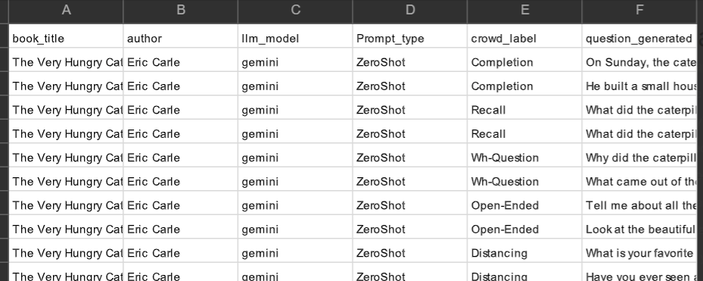

Phase 4: Human Evaluation of Questions

4.1 Human Evaluation Setup
Tasks
- Build annotation interface (Sheets / Qualtrics)
- Blind raters to:
  - Model
  - Human vs LLM origin
- Randomize order
Deliverables
- Human evaluation protocol
- Rater training document

4.2 Human Scoring
Tasks
- Score all questions using rubric
- Track time-on-task
- Collect qualitative comments
Deliverables
- human_eval_scores.csv
- human_eval_comments.csv

4.3 Human vs LLM Comparison
Tasks
- Aggregate scores by:
  - Model
  - Prompt type
  - Human vs LLM
- Statistical testing:
  - ANOVA / mixed-effects models
Deliverables
- Comparison tables
- Plots for thesis Results section

Phase 5: LLM-as-a-Judge Evaluation

5.1 Judge Prompt Design
Tasks
- Convert rubric into evaluation prompt
- Enforce structured scoring output
- Test judge consistency
Deliverables
- LLM judge prompts
- Output schema

5.2 LLM Judging Runs
Tasks
- Have LLM score:
  - LLM-generated questions
  - Human-generated questions
- Repeat runs for stability
Deliverables
- llm_judge_scores.csv

5.3 Alignment Analysis
Tasks
- Compare LLM vs human scores:
  - Per dimension
  - Overall agreement
- Metrics:
  - Correlation
  - κ / ICC
Deliverables
- Alignment analysis report
- Dimension-wise reliability insights

Phase 6: Automated Evaluation of Human Questions

6.1 Feature Extraction
Tasks
- Extract:
  - Length
  - Syntax features
  - Embeddings
- Label with human rubric scores
Deliverables
- Feature matrix
- Label set

6.2 ML & LLM-Based Models
Tasks
- Train lightweight regressors/classifiers
- Compare with LLM-only evaluation
Deliverables
- Model performance tables
- Feasibility assessment

Phase 7: Synthesis, Interpretation, and Reporting

Tasks
- Identify:
  - Where LLMs excel
  - Where they fail
  - What humans do better
- Connect findings to pedagogy

7.2 Writing & Artifacts
Deliverables
- Thesis chapters:
  - Methods
  - Results
  - Discussion
- Public artifacts:
  - Rubric
  - Prompt templates
  - Evaluation protocol

